**Assignment No:-15**

Name:-Suryawanshi Sangramsingh Sambhaji

Batch: - Delta - DCA (Java) 2024 Date:-22/5/2024

**1. Write a java program to find all the palindrome numbers from the array.**

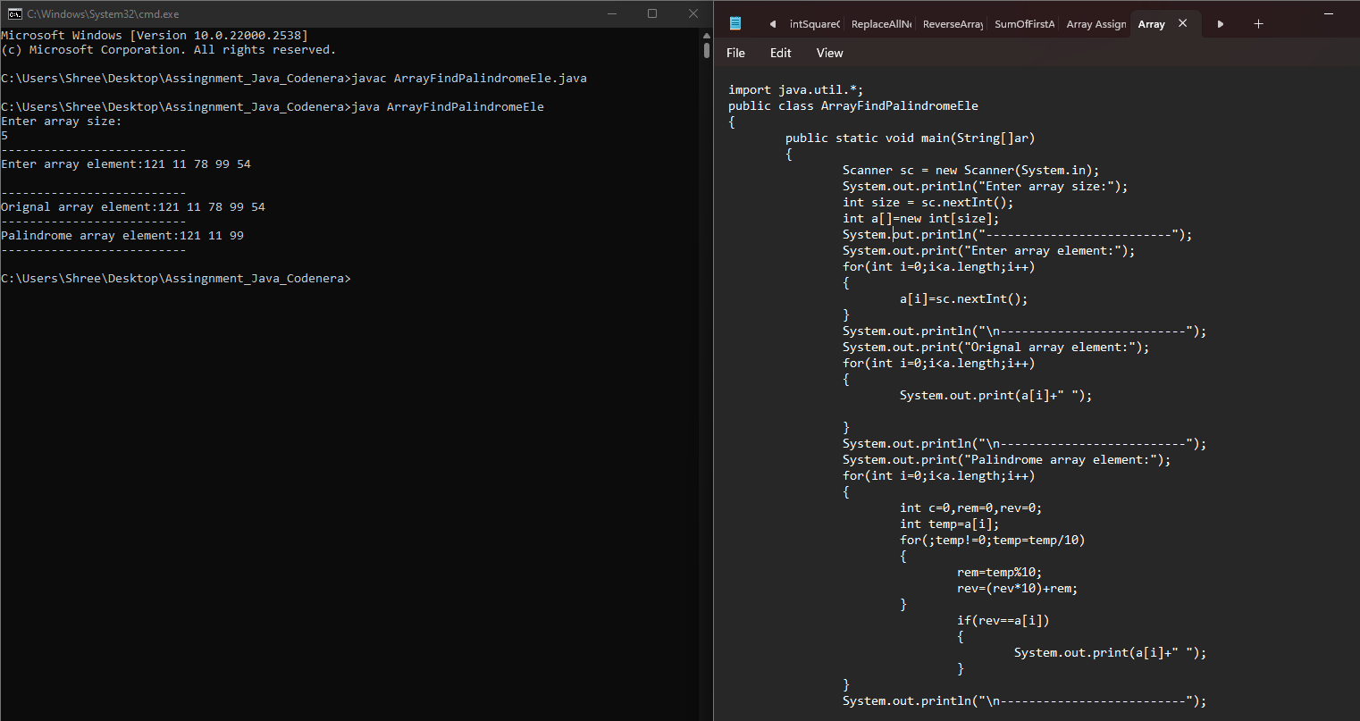

**2. Write a java program to find all the prime numbers from the array.**

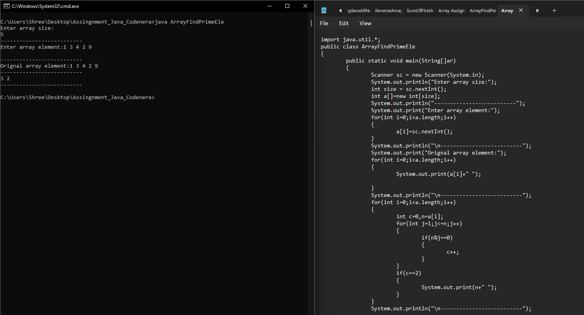

**3.** **Write a java program to find all the Armstrong numbers from the array.**

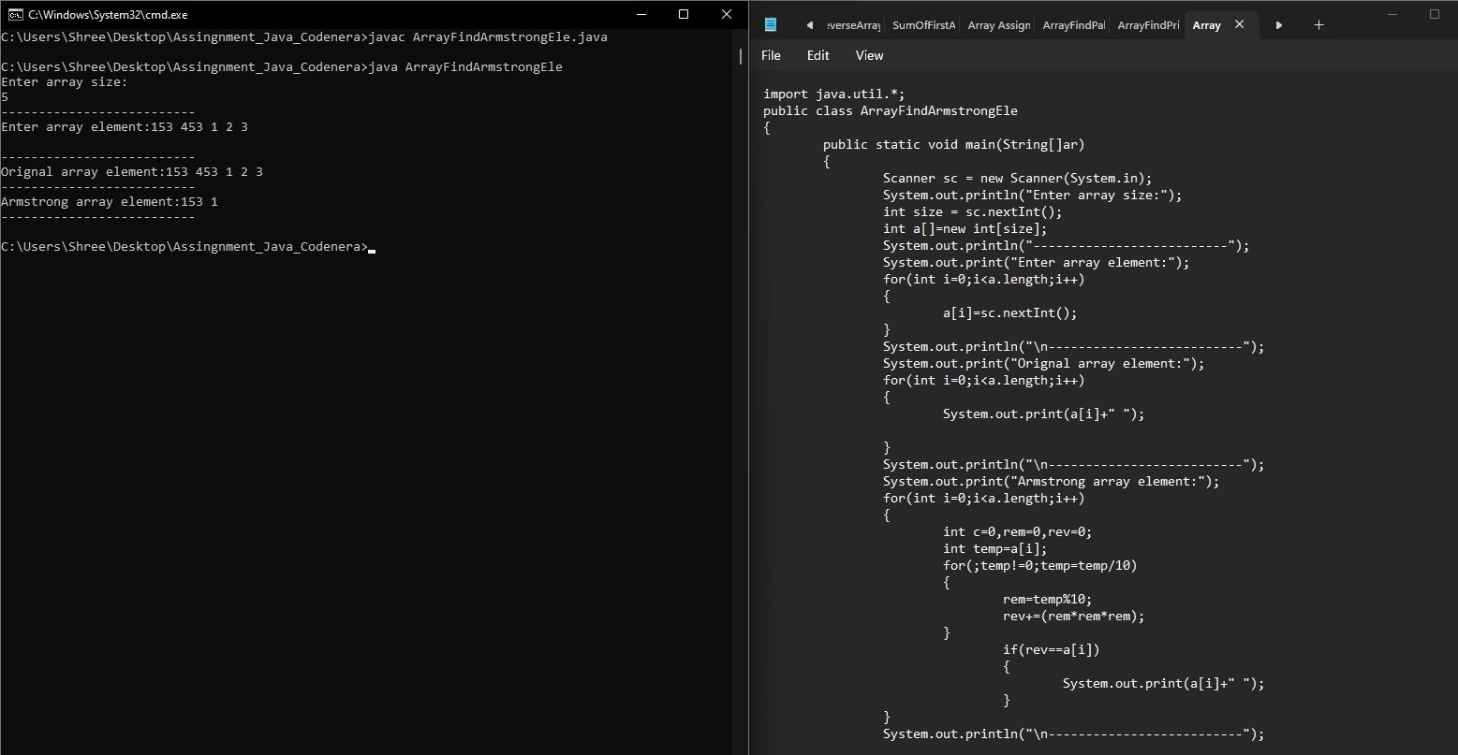

**4.** **Write a java program to find all the duplicate numbers from the array.**

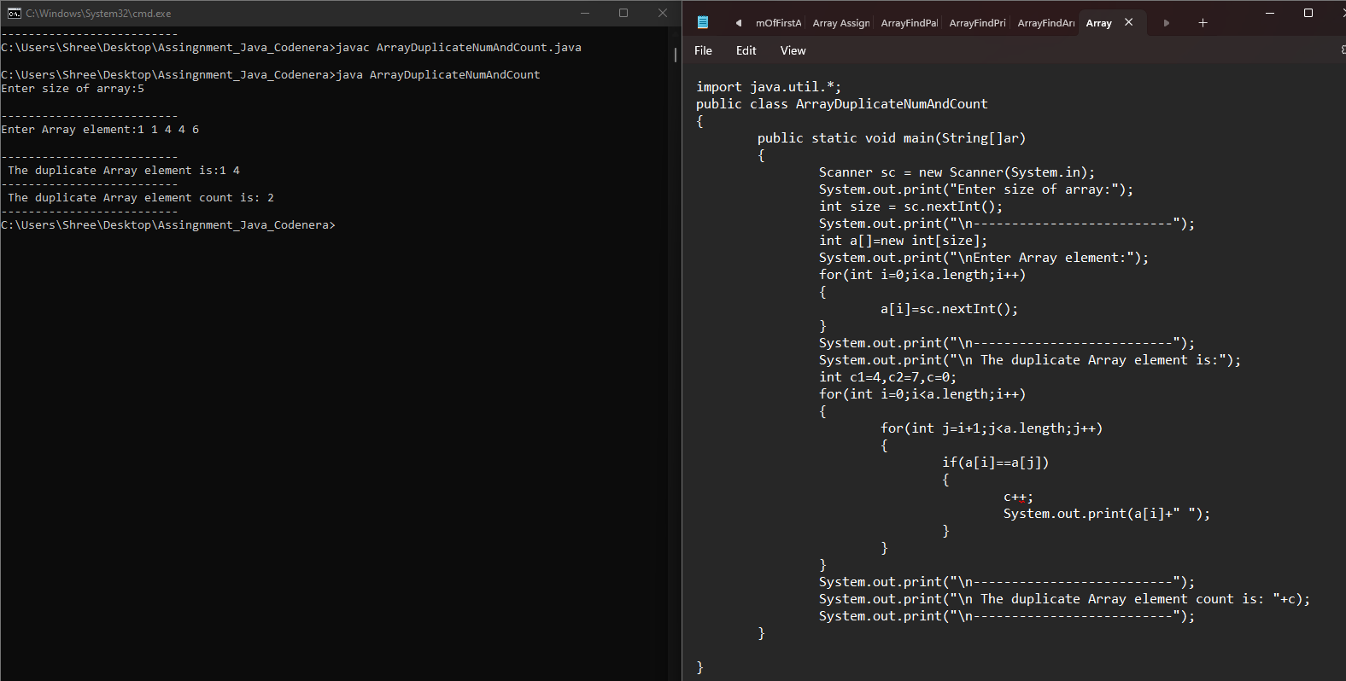

**5. Write a program to check if an array of integers contains two specified elements.**

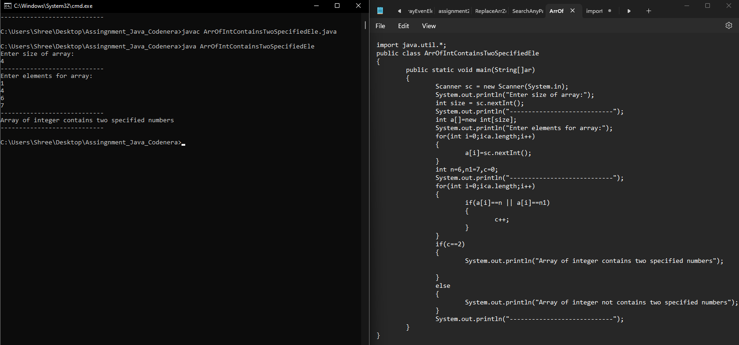

**6. Write a program replace all negative value with its immediate left elements square. Means arr[] = [12, 3, -19, 29, 5, -61, 44, 7, -9] Output array will be [12, 3, 9, 29, 5, 25, 44, 7, 49].**

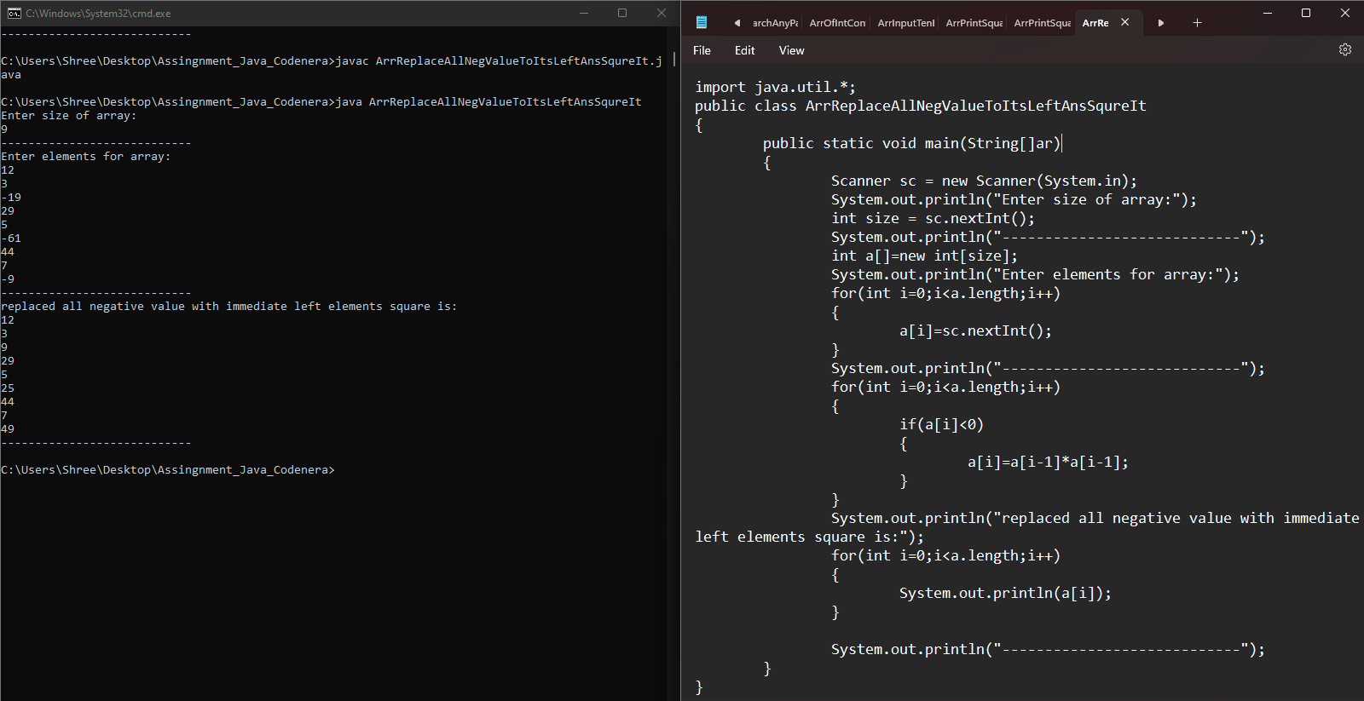

**7.** **Write a program enter an array and print it in reverse order.**

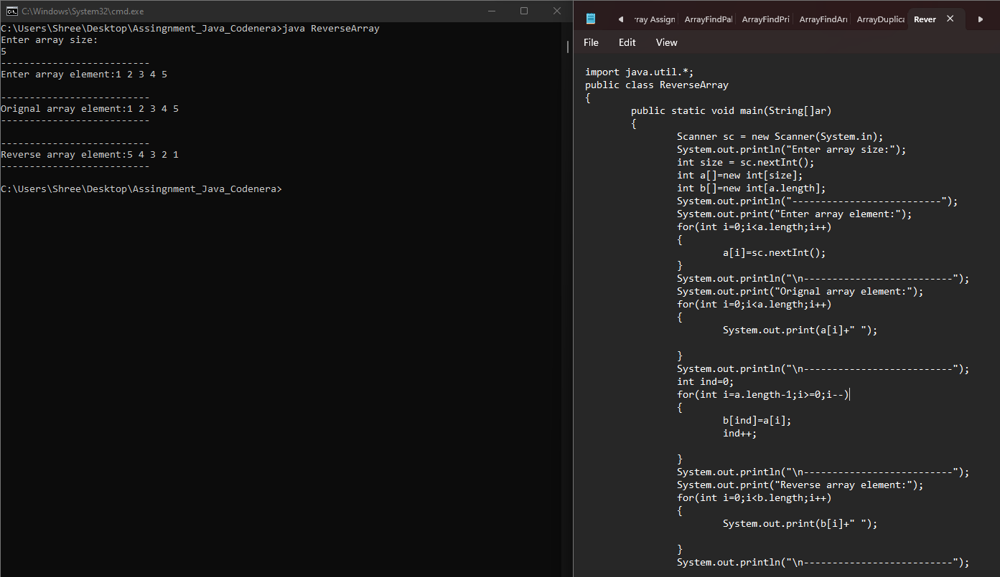

**8. Write a program enter an array and find the no in array which is equal to the sum of 1st and last element.**

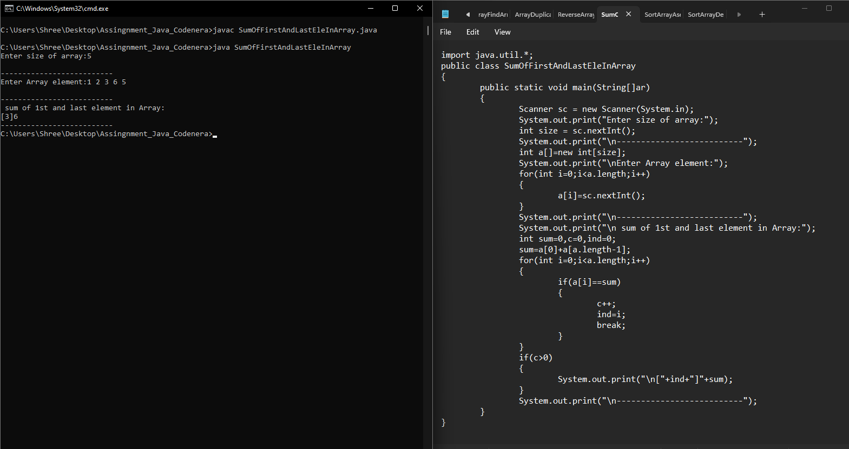

**9. Write a program enter an array and sort that in ascending order.**

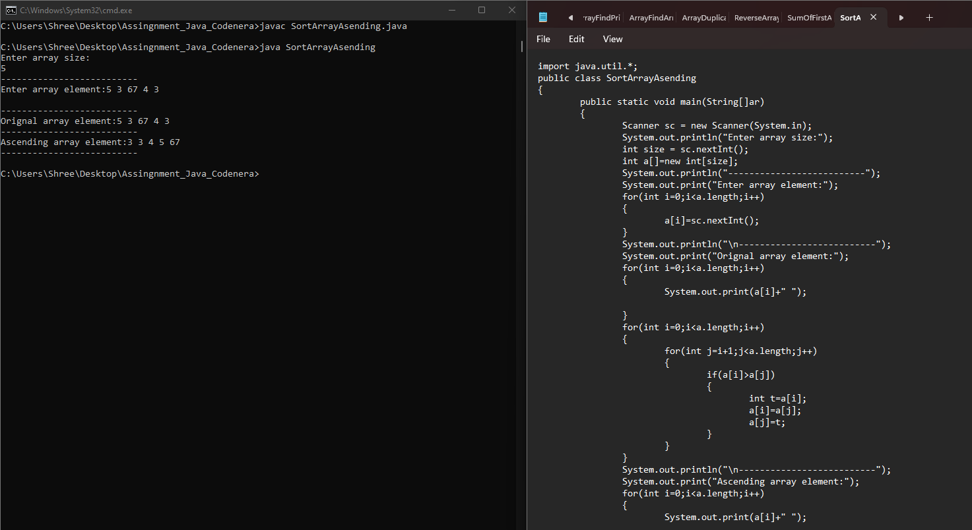

**10. Write a program enter an array and sort that in descending order.**

